Advanced Algebra 2 Name: _______________________ Period: ________
Unit 2A Reassessment (Maximum possible grade 90)

Problems 1-6 The function $f\left(x\right)=\left|x\right|$ has been transformed to create the functions graphed below. Match each graph to its transformed equation.
- __________  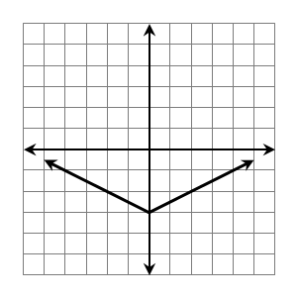 | - __________  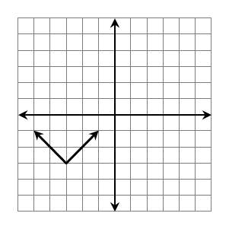 | - $y=-\left|x-3\right|$  - $y=-\left|x+3\right|$  - $y=\frac{1}{2}\left|x\right|-3$  - $y=2\left|x\right|-3$  - $y=\left|x-3\right|+3$  - $y=\left|x+3\right|-3$
- __________  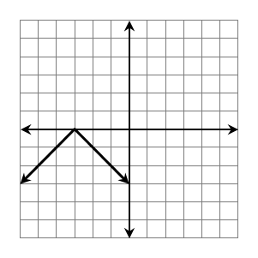 | - __________  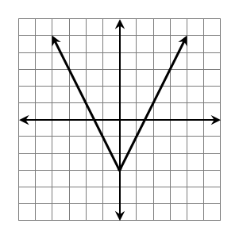
- __________  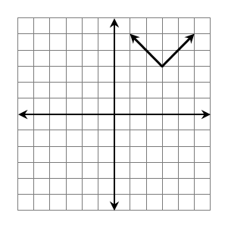 | - __________  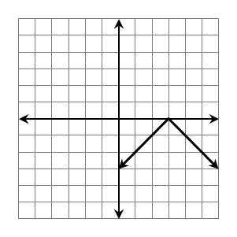

Problems 7-8 Given $f\left(x\right)=|x|$, use the verbal description provided to write an equation.
7. Reflected over the x-axis, Vertically compressed by $\frac{1}{2}$, shifted right 50 units and shifted up 25 units.

8. Vertically stretched by 3, shifted down 10 units.
9.
The function $f\left(x\right)=|x|$ is vertically stretched by a factor of $3$, reflected over the x-axis and translated 7 units down.
- Graph the transformed function.  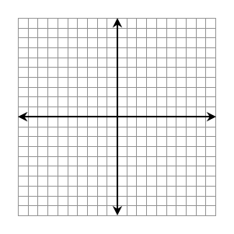 | - Write an equation for the transformed function.
 | - Write the domain and range of the transformed function.

Using the equation provided answer the questions 10-17: $f(x)=-3\left|x+5\right|+6$
10. The function notation description is:
A. $f(x)=-3\left|x+5\right|+6$
B. $-3f(x+5)+6$
C. $f-3(x+5)+6$
D. $3f-(x+5)+6$
11. Provide the verbal description of this function.


12. Graph this function.

13. The vertex of the function is: A. $(-5,-6)$ B. $(-6,-5)$
C. $(-5, 6)$ D. $(5,-6)$
14. The domain of the function is:
A.$(-∞,-2]$ B. $[5, -∞)$
C.$(5,-∞)$ D. $(-∞, ∞)$
15. The range of the function is:
A. $(-∞, ∞)$ B. $[6, -∞)$
C.$(6,-∞)$ D. $(-∞,-5]$
16. This function has a minimum of (-5, -6).
A. True B. False
17. Provide the axis of symmetry.

